NAV-VIR-an audio-tactile virtual environment to assist visually impaired people

Haptic feedback Map Motor

【Main Content】:

This paper introduces the NAV-VIR system, a multimodal virtual environment to assist visually impaired people in virtually discovering and exploring unknown areas from the safety of their home. The originality of NAV-VIR resides in (1) an optimized representation of the surrounding topography, the spatial gist, based on human spatial cognition models and the sensorimotor supplementation framework, and (2) a multimodal orientation-aware immersive virtual environment relying on two synergetic interfaces: an interactive force feedback tablet, the F2T, and an immersive HRTF-based 3D audio simulation relying on binaural recordings of real environments.

【NAV-VIR】：**It is realized by a joystick and two motors on the screen, instead of traditional piezoelectric, electrostatic, ultrasonic, etc.**

NAV-VIR is a dynamic Human-Machine Interface (HMI) able to provide a comprehensive and intuitive spatial representation through audio-tactile feedback. The NAV-VIR system is comprised of two synergetic parts (cf. fig 2): (1) an interactive tactile interface, the F2T (Force Feedback Tablet [4]), to provide intuitive spatial information about possible paths, and (2) a dynamic audio environment that provides a realistic orientation-aware 3D simulation of the audio cues the VIP are likely to encounter during their actual journey.

**ARCHITECTURE AND FUNCTIONALITIES：**

The general use scenario of NAV-VIR can be summarized as follows: (1) the user chooses an area to explore through audio commands, (2) the map is loaded from a GIS provider and automatically converted into its equivalent topological representation, (3) known PoIs are uploaded from the GIS (e.g. cafés, shops, roads, churches, fountains) and converted into localized sound sources which will make up the audio layer of the virtual environment. This audio-enhanced navigation graph is accessed through the F2T, which allows the user to explore the map with the use of a joystick controlled by a force feedback mechanism. The spatialized audio PoIs are conveyed through a standard pair of headphones.

1. **NAV-VIR Tactile Interface**
2. The F2T (fig 3) provides the means to explore graphical content by re-encoding visual or spatial information as bi-dimensional force feedback. It is an interactive and dynamic 2D haptic interface that relies on force feedback to interact with the user.
3. The F2T can provide both a passive (resisting or facilitating movement) or an active feedback (forced movement) during the exploration. Passive feedback is used to convey information about the map during a free exploration, while the active feedback is used to provide direct guidance along a path. Examples of simple “tactile images” can be seen in figure 4, where colors represent different types of frictions.
4. Based on the functional mapping between the user’s actions (movement direction, speed and acceleration) and the tablet’s response, we can distinguish 2 basic categories of passive feedback. The “solid” type of friction, where the user has to push the joystick with a force above a given threshold for it to move at all. This type of friction could be used to simulate ridges or edges, or to block the user’s movement if he were to try to move over a non-walkable area while exploring a map. On the other hand, a “fluid” friction represents a linear response to the user’s movements: the resistance generated by the F2T is directly proportional to the force applied by the user. Different levels of fluid friction could be used to represent different types of terrains (pavement, park, …).

(For example, "canyons", in which case attempts to exit the "canyon" from either side will result in fluid friction-type resistance that the user will then push back to the bottom of the canyon. These canyons can be used to indicate "walkable" paths Or areas, allowing free exploration of the surroundings while keeping users inside the "gorge" to prevent them from getting lost on the map.)

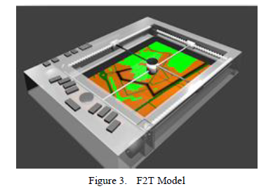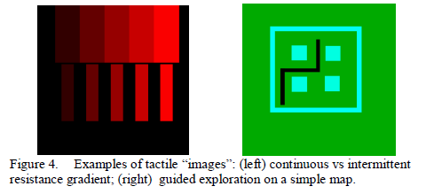

1. **NAV-VIR Spatialized Audio Environment**

【Experiments】：

The first is to assess whether participants can perceive the direction of simple movements produced by F2T (active feedback). The second aims to evaluate the perception of simple geometric shapes that can also be represented through active feedback, such as squares, circles, and triangles.

**Results:** Most of our participants were able to correctly identify the direction of motion generated by the device (µ = 85.7%, σ = 9%) and were able to identify simple geometric shapes (µ = 94.6%, σ = 6,8%) (Figure 6) .

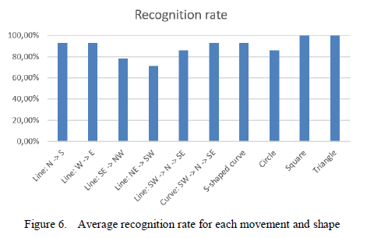

【Important Reference】：

[3] A. M. Brock, P. Truillet, B. Oriola, D. Picard, and C. Jouffrais,“Interactivity improves usability of geographic maps for visually impaired people,” Human–Computer Interact., vol. 30, no. 2, pp. 156–194, 2015.